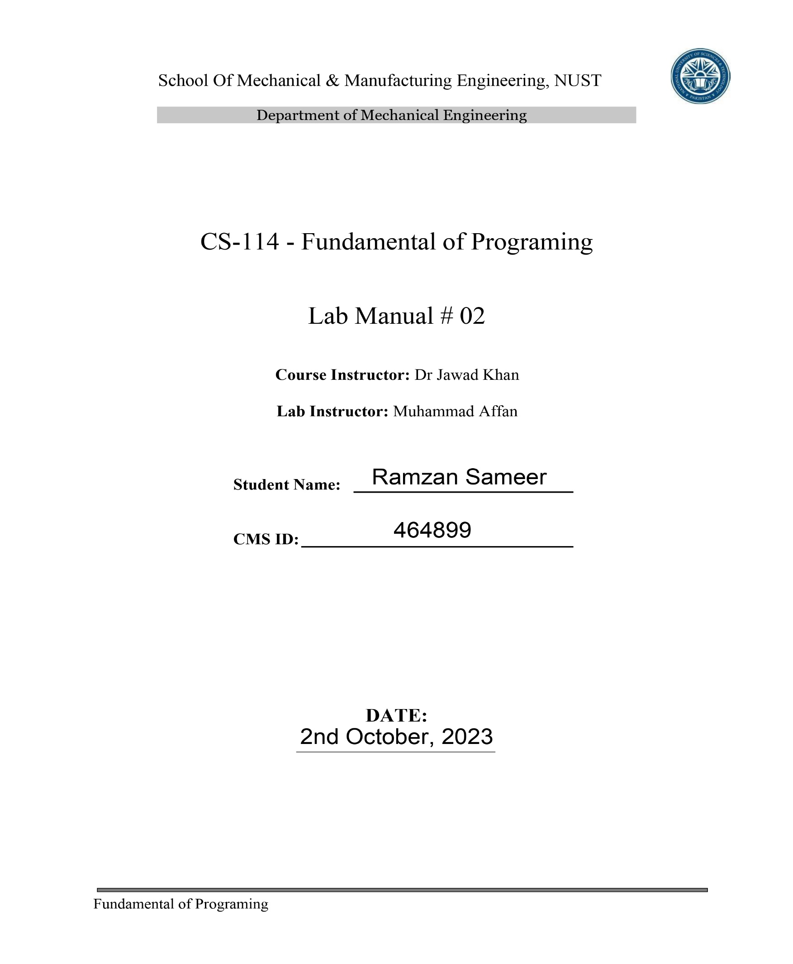

Q1. Write a C++ program to calculate distance between two points. The values should of coordinates should be input by user:

Code and Result:

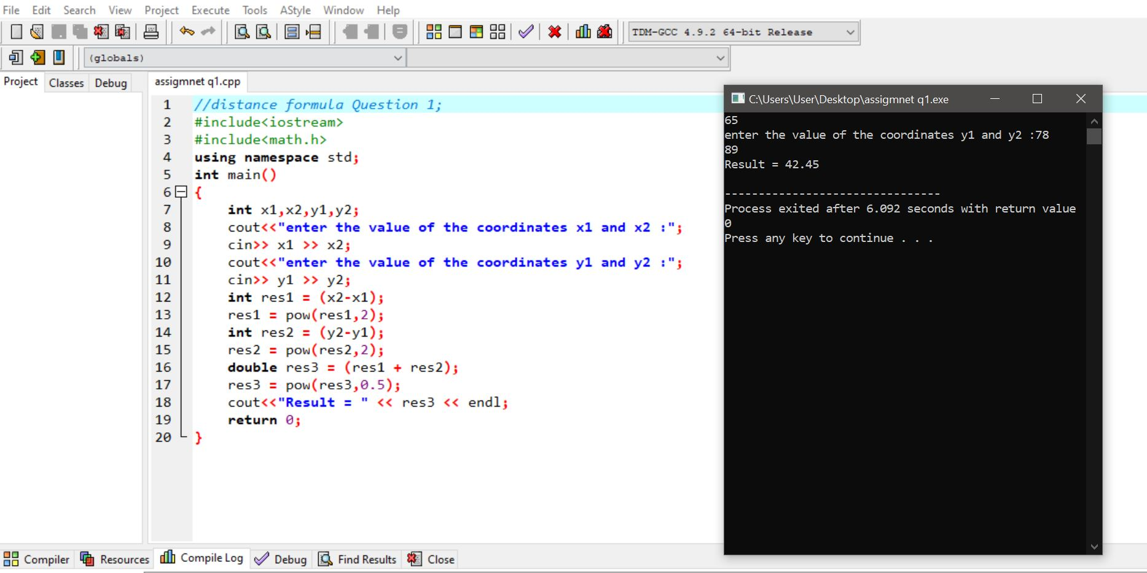

Q2. Write a code in C++ to take length from user in centimeter and convert it into meter and kilometer:

Code and Result:

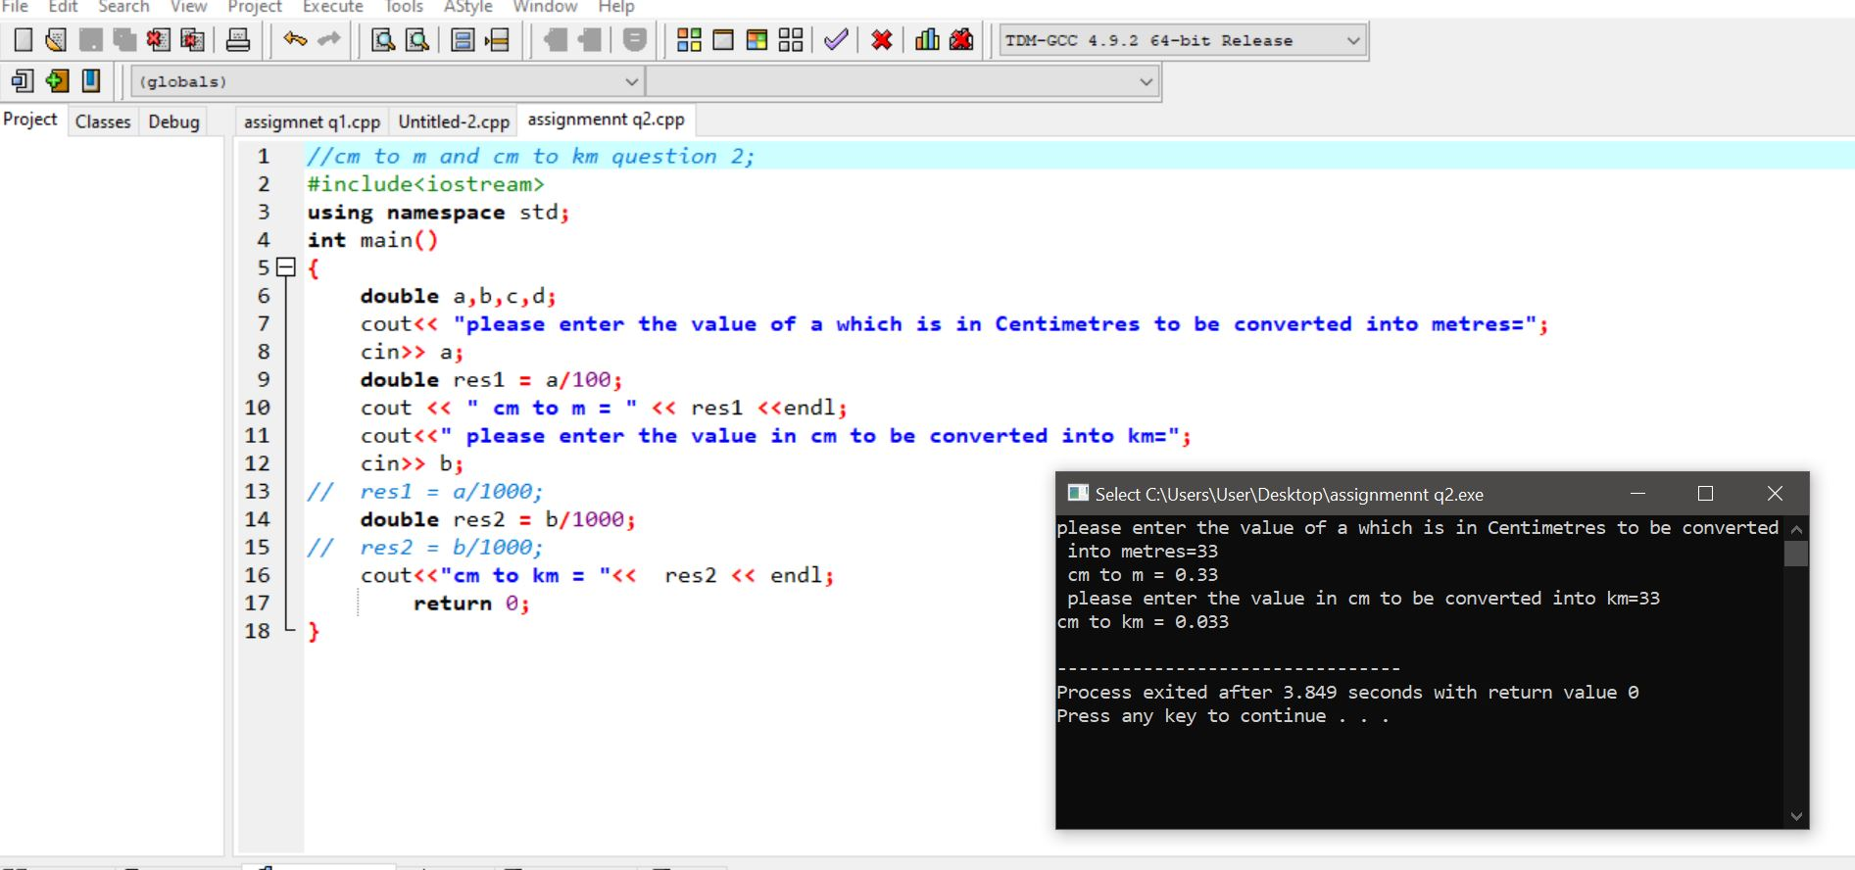

Q3. Write a code in C++ that takes values of a and b from the user and displays result of polynomial 𝑎 2 + 2𝑎𝑏 + 𝑏 2 :

Code and Result:

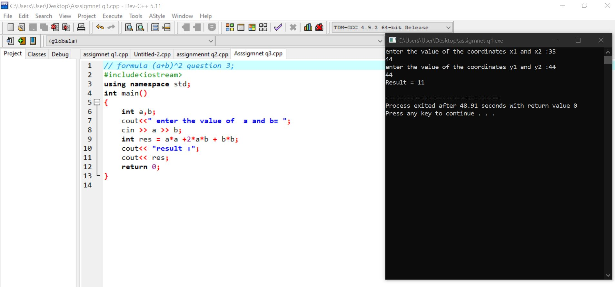

Q4. Write a program in C++ to convert temperature in Fahrenheit to Celsius:

Code and Result:

